Spring Security
Q. What is Spring Security?
Spring Security is a comprehensive framework for securing Java applications, providing robust authentication, authorization, and protection against common security threats. It integrates seamlessly with the Spring ecosystem and supports a variety of security mechanisms, including form-based login, OAuth2, LDAP, and method-level security.

Q. What is authentication and authorization in the context of Spring Security?
- Authentication: This refers to the process of verifying the identity of the user, using the credentials provided when accessing certain restricted resources. Two steps are involved in authenticating a user, namely identification and verification. An example is logging into a website with a username and a password. This is like answering the question Who are you?
- Authorization: It is the ability to determine a user's authority to perform an action or to view data, assuming they have successfully logged in. This ensures that users can only access the parts of a resource that they are authorized to access. It could be thought of as an answer to the question Can a user do/read this?

Q. What are the differences between authentication and authorization?
Authentication
- Definition: The process of verifying the identity of a user or system.
- Purpose: To confirm that the user is who they claim to be.
- Mechanism: Typically involves credentials such as usernames, passwords, biometric data, or tokens.
- Outcome: Determines if the user can log in or access the system.

Authorization
- Definition: The process of determining what an authenticated user is allowed to do.
- Purpose: To control access to resources and actions based on the user's permissions.
- Mechanism: Involves roles, permissions, and policies that dictate what actions are permitted.
- Outcome: Determines what resources and operations the user can access after being authenticated.
Key Differences
- Sequence: Authentication occurs before authorization.
- Focus: Authentication is about identity verification; authorization is about access control.
- Authentication: Logging into a website with a username and password.
- Authorization: Granting access to specific features or data based on the user's role (e.g., admin, user, guest).

Q. What are the main features of Spring Security?
Authentication:
Spring Security provides a variety of authentication mechanisms, including form-based authentication, HTTP basic authentication, OAuth2, and OpenID Connect.
Authorization:
Spring Security provides a powerful authorization framework that allows you to control access to your application's resources based on user roles, permissions, and other factors.
CSRF protection:
Spring Security provides protection against Cross-Site Request Forgery (CSRF) attacks.
Session management:
Spring Security provides a variety of session management options, including session fixation protection and cookie-based sessions.
Secure password hashing:
Spring Security provides a secure password hashing mechanism that helps to protect your users' passwords from being compromised.

Q. How do you configure Spring Security in a Spring Boot application?
- Add the Spring Security dependency to your pom.xml file.
- Create a Security Configuration Class and Enable Spring Security by adding the @EnableWebSecurity annotation to your Spring Boot configuration class.
- Configure authentication. You can use in-memory authentication, JDBC authentication, LDAP authentication, or OAuth2 authentication.
- Configure authorization. You can use Spring Security's built-in authorization features or create your own custom authorization rules.
- Secure your endpoints. You can use Spring Security's annotations or its web security expression language (SpEL) to secure your endpoints.

Q. What is the use of the @EnableWebSecurity annotation?
The @EnableWebSecurity annotation is a Spring Security interface that can be used to configure a web application's security settings and define security rules and policies. It can be added to an @Configuration class, and can be used in any WebSecurityConfigurer or by exposing a SecurityFilterChain bean.

Q. What is the role of SecurityContext in Spring Security?
The SecurityContext in Spring Security holds the authentication information of the currently authenticated user, including their credentials and roles. Managed by the SecurityContextHolder, it allows access to this information throughout the application, enabling security checks and decisions based on the user's authentication status and authorities.

Q. Explain WebSecurityFilterChainAdapter?
- This class is a convenient base class for creating a Web Security configuration. It provides methods that allow you to configure web-based security for specific HTTP requests.
- However, as of Spring Security 5.4, it's worth noting that WebSecurityConfigurerAdapter is considered deprecated, and the recommended approach is to use SecurityConfigurerAdapter directly or define SecurityFilterChain beans.

Q. What do you mean by basic authentication?
RESTful web services can be authenticated in many ways, but the most basic one is basic authentication. For basic authentication, we send a username and password using the HTTP [Authorization] header to enable us to access the resource. Usernames and passwords are encoded using base64 encoding (not encryption) in Basic Authentication. The encoding is not secure since it can be easily decoded.

Q. What is PasswordEncoder?
Password encoding is provided by Spring Security using the PasswordEncoder interface. This interface defines two methods:
- encode(): It converts a plain password into an encoded form.
- matches(): It compares an encoded password from the database with a plain password (input by the user) that's been encoded using the same salting and hashing algorithm as the encoded password.

Q. Explain salting and its usage.
- Spring Security automatically applies salting since version 3.1. Salting is the process of combining random data with a password before password hashing.
- Salt improves hashing by increasing its uniqueness and complexity without increasing the requirements for users, thereby reducing password attacks.
- Hashed passwords are then stored in a database, along with salt. Your application will be protected from Dictionary-Attack by using salting.
- With Salt, you can add an extra string to the password to make it more difficult for hackers to crack it.
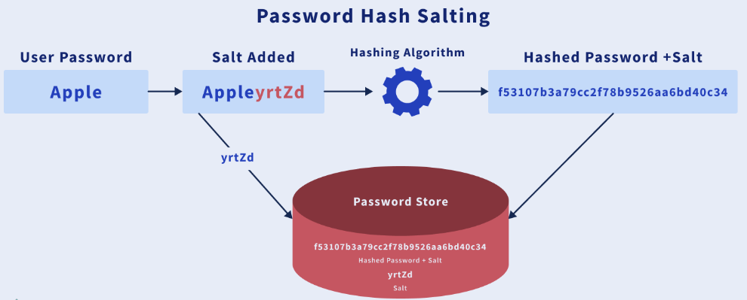

Q. What do you mean by HASHING in spring security?
Databases often suffer from security problems when storing passwords. Plain text passwords cannot be stored in your database because then anyone who has access to the database would know the passwords of every user. The solution to this problem is to store encrypted passwords in a database. This is called password hashing.

Q. Explain SecurityContext and SecurityContext Holder in Spring security.
- SecurityContext: In this, information/data about the currently authenticated user (also known as the principal) is stored. So, in order to obtain a username or any other information about the user, you must first obtain the SecurityContext.
- SecurityContextHolder: Retrieving the currently authenticated principal is easiest via a static call to the SecurityContextHolder. As a helper class, it provides access to the security context. By default, it uses a ThreadLocal object to store SecurityContext, so SecurityContext is always accessible to methods in the same thread of execution, even if SecurityContext isn't passed around.

Q. what is SecurityFilterChain in spring security
In Spring Security, SecurityFilterChain is a key component that defines the sequence of security filters to be applied to HTTP requests. It is a core part of Spring Security's architecture, allowing for the configuration of various aspects of web security, such as authentication, authorization, session management, and more.

Q. What is BCryptPasswordEncoder() method in spring security
BCryptPasswordEncoder is a class provided by Spring Security that implements the PasswordEncoder interface. It is used to perform secure password hashing using the BCrypt hashing algorithm. The BCryptPasswordEncoder method is commonly used to encode passwords before storing them in a database and to verify user-entered passwords during authentication.

Q. UserDetailsService and UserDetails
In Spring Security, the UserDetailsService interface is a core component used for loading user-specific data. It is responsible for retrieving user information from a backend data source, such as a database or an external service, and returning an instance of the UserDetails interface.

The UserDetailsService interface has a single method called loadUserByUsername(), which takes a username as a parameter and returns a fully populated UserDetails object. The UserDetails object represents the authenticated user in the Spring Security framework and contains details such as the user’s username, password, authorities (roles), and additional attributes.

